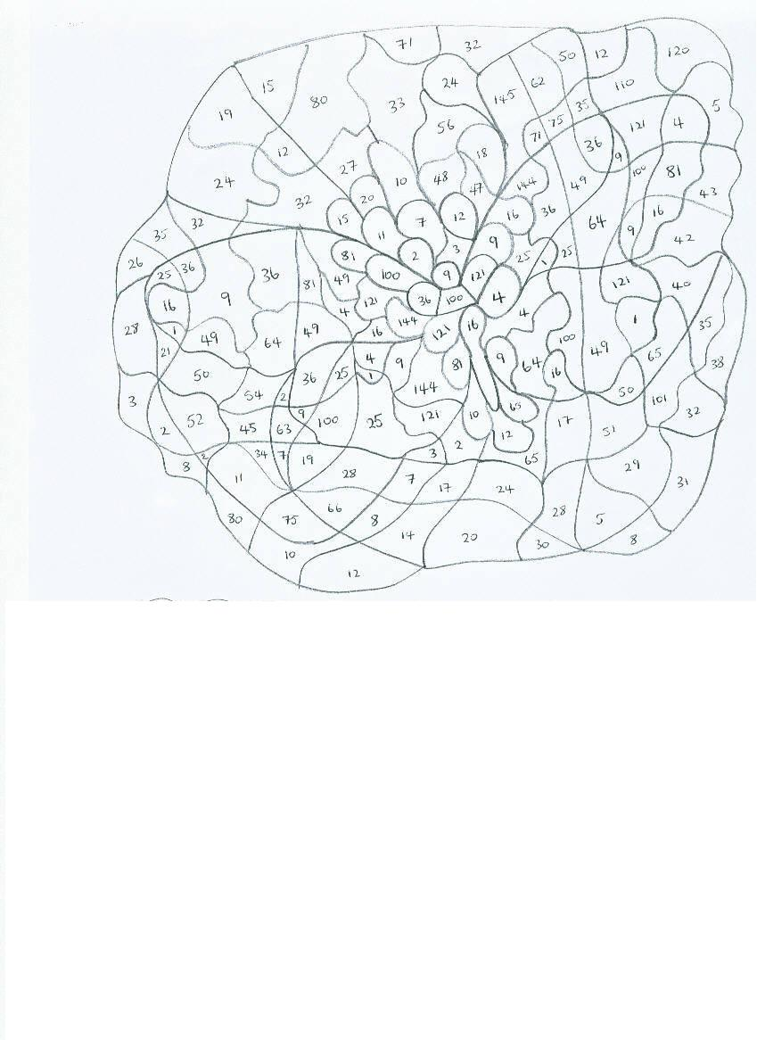Can you find what the picture is by shading all the square numbers?